9SSlGNMENT - 

# Team ID: PNT2022TMlD50299

Write code and connections in wokwi for ultrasonic sensor. Whenever distance is less than 100 cms send alert to ibm cloud and display in device recent events. Upload document with wokwi share link and images of ibmcloud.

Code:

#include <WiFi.h>

#include <PubSubC1ient.h>

WiFiC1ient wifiC1ient;

String data3;

#define ORG "9djwz2"//1BM ORGANITION ID

#define DEVICE_TYPE "newiot"//Device type mentioned in ibm watson IOT Platform

#define DEVICE_ID "123456"/ [Device ID mentioned in ibm watson IOT Platform

#define TOKEN "29082e01"

#define speed e. 034 #define led 14 char server[] = ORG " . messaging. internetofthings.ibmcloud . com" ; char publishTopic[] = "iot-2/evt/event_1/fmt/json" ; char topic[] = iot-2/cmd/1ed/fmt/String" ; char authMethod[] - " use-token-auth " ; char token[] = TOKEN; char clientld[] = ORG DEVICE TYPE DEVICE ID;

PubSubC1ient client(server, 1883, wifiC1ient);

const int trigpin=5; const int echopin=18; String command; String data=

long duration; float dist; void setup()

Serial . begin (115200); pinMode(1ed, OUTPUT); pinMode(trigpin, OUTPUT); pinMode(echopin, INPUT); wifiConnect( ) ; mqttConnect( ) ;

void loop() { bool isNearby = dist < 100; digitalWrite(1ed, isNearby);

publishData(); delay(soe);

## if ( !client.loop()) { mqttConnect() ;

void wifiConnect() {

Serial. print("Connecting to Serial. print("Wifi"); WiFi . begin( "Wokwi-GUEST" , 6); while (WiFi.status() WL_CONNECTED) { delay (500) ;

## Serial. print( )

Serial. print("WiFi connected, IP address: Serial . print1n(WiFi . locallP());

void mqttConnect() { if ( ! client. connected()) {

Serial. print("Reconnecting MQTT client to Serial. println(server); while ( ! client. connect(clientld, authMethod, token)) {

Serial. print( " . delay(5Ø0) ;

initManagedDevice() ;

## Serial. println();

void initManagedDevice() { if (client. subscribe(topic)) {

## // Serial. println(client.subscribe(topic));

Serial. print1n("IBM subscribe to cmd OK"); } else {

Serial. println("subscribe to cmd FAILED");

void publishData()

digitalWrite(trigpin, LOW) ; digitalWrite(trigpin, HIGH) ; delayMicroseconds (10) ; digitalWrite(trigpin, LOW) ; duration=pulseln (echopin, HIGH) ; dist=duration*speed/2; if(dist<100){

String payload = "{\"A1ert Distance\" : "; payload += dist; payload

## Serial. print( " ) ;

Serial. print("Sending payload: Serial. print In (payload) ; if (client. publish(pub1ishTopic, (char* ) payload.c_str())) {

Serial. print1n("Pub1ish OK");

if(dist>1Ø0){

String payload = " { \ "Distance\" : " ; payload +2 dist; payload

## Serial. print( "\n" ) ;

Serial. print("Sending payload:

Serial. println (payload) ; if(c1ient.pub1ish(pub1ishTopic, (char* ) payload. ) ) 

Serial. print1n("Pub1ish OK");

## }else {

Serial. print1n("Pub1ish FAILED");

Connections:

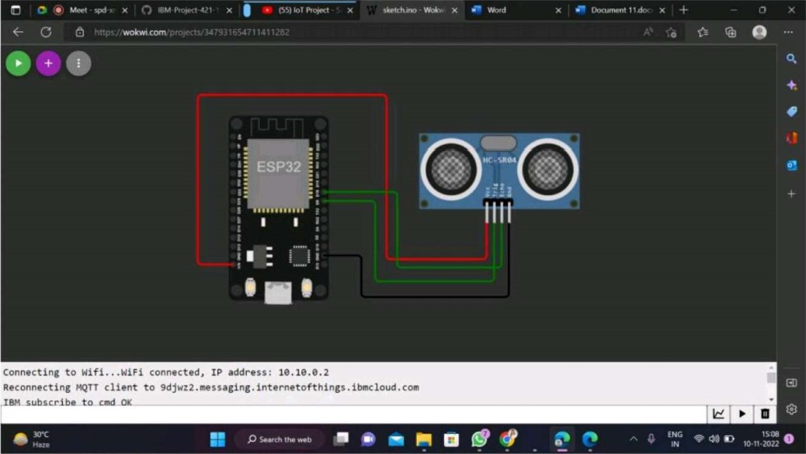

Output:

Ass , O

|  |  |  |  |  |
| --- | --- | --- | --- | --- |
|  |  |  |  |  |
| Browse Action Devee T Interfaces Add | | | Device O |  |
|  |
|
|
|
|

10-11-2022

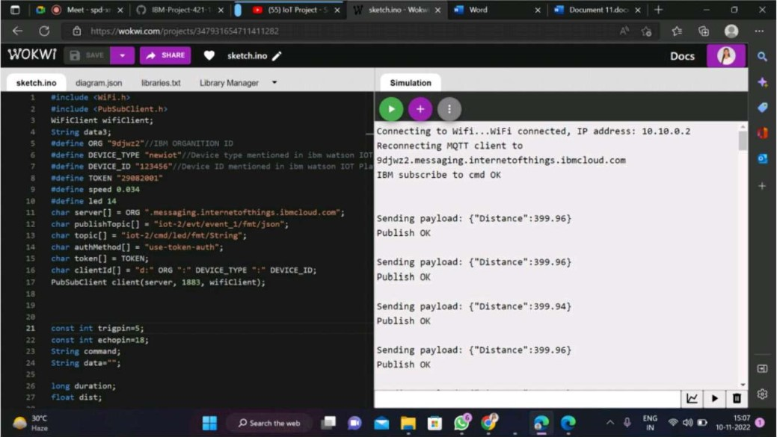

Wokwi link:

### https://wokwi.com/proiects/347931654711411282